Tomra Altium – User Instructions

# Table of Contents

Tomra Altium – User Instructions 1

1. Table of Contents 2

2. Revision Log 4

3. Introduction 5

4. Installing Altium 5

4.1 Create Altium Live User 5

4.2 Download and Install Altium 5

4.3 Log in in Altium and review license status 5

5. Initial Setting in Altium 6

5.1 Template Folder 6

5.2 Designator Placement 6

5.3 History 7

5.4 File locking 7

6. Library at GitHub 8

6.1 Accessing GitHub library 8

6.2 Using the GitHub library in Altium 9

6.3 Known issues 10

7. Symbols 11

7.1 Edit symbol for Altium use 11

7.2 General 11

7.3 IC 12

7.4 Connectors (Micro-fit, pin headers and similar) 12

8. Drawing Schematics 14

8.1 Components that are not to be mounted 14

8.2 Template 15

9. Footprints 16

9.1 Layer utilization 16

10. Layout 18

10.1 Layer utilization 18

10.2 Design Rules 18

10.3 Drill Table 18

10.4 Output Job Files 19

10.5 Gerber Files 19

11. MCAD Cooperation 20

12. Tips and Tricks 21

12.1 Schematic 21

12.2 Layout 21

13. For the future….. 22

# Revision Log

|  |  |  |  |  |
| --- | --- | --- | --- | --- |
| **Date** | **Sign** | **Description of Change** | **Chapter** | **Page** |
| 2020-02-06 | SJ | Initial Draft |  |  |
| 2020-02-25 | SJ | Changed path on examples and templates |  |  |
| 2020-03-18 | ERM | Added info on OutJob examples and new BOM template |  |  |
|  |  |  |  |  |

# Introduction

Altium has been selected as the new ECAD tool for Tomra. This document aims to give instructions on how to install the tool and give some guidelines on how to use it.

# Installing Altium

## Create Altium Live User

In order to download Altium and get access to the licenses an Altium Live User account must be created for each individual user. This is done by one of the administrators at:

<https://dashboard.live.altium.com/#Contacts>

## Download and Install Altium

Current version of Altium in use at Tomra is version 19. (version 20 has not yet been evaluated, but the transition should be seamless). Altium Designer can be downloaded here:

<https://www.altium.com/products/downloads>

Download this and install it.

## Log in in Altium and review license status

When Altium is installed the user must log in to the Altium Live account in Altium Designer.

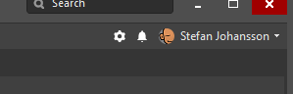

Click your name in the top right corner and click “Licenses”. This screen shows all available licenses. Tomra currently has one full license and three schematic only (“Altium Schematic SE”) licenses.

Please use the schematic only when you only need to edit schematics.

# Initial Settings in Altium

There are a number of settings that must be done in Altium for it to run the way that we want.

## Template Folder

A Tomra template for schematics has been created for different sheet sizes and an Excel BOM template file as also available.

Set Template folder under (you will need to go trough chapter 6 first)

Preferences -> Data Management -> Templates to

“(your local repository folder)\DOC\Templates”

The Template folder is on Github for simple sharing and revision control.

## Designator Placement

To get correct placement of designator and comments on symbols when the they are placed on the schematics the defaults must be used. Change the following:

Preferences -> Schematic -> Defaults -> Designator

Check the box for “Override Library Primitive”.

Also make sure that “Autoposition” is ticked off for the designator placement. This is default, but it is important that this setting is selected.

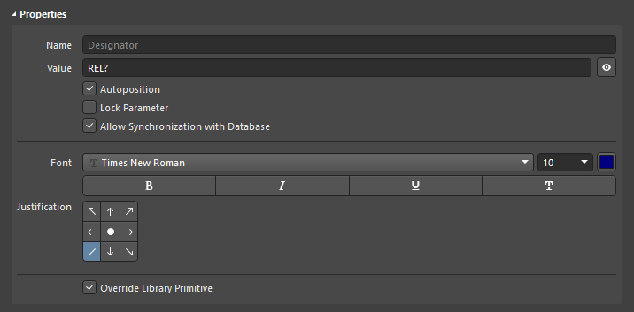

## History

Change history to fewer days. Tools -> Preferences -> Data Management -> Local History. Set number of days to one or two days. This is to avoid that too much data is stored on the server.

## File locking

Currently, files are stored at a file server. This means that there is a risk that two users open the same design files and overwrites each other’s changes. There is also a risk that design files gets corrupted in this process.

To prevent this from happening there is a feature in Altium called “File Locking”. See Tools -> Preferences -> Data Management -> File locking and enable the two tick boxes for file locking features.

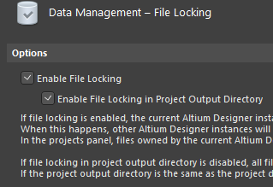

There will now be a green padlock next to files in the projects panel that you can save. Other uses will not be able to save changes to these files.

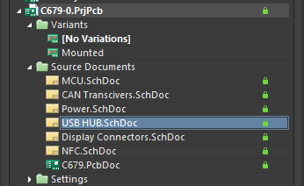

# Library at GitHub

The Tomra Altium Library has ben placed at GitHub to have revision control. It is a library that based on a database. Schematic symbols and footprints are stored in .schlib and .pcblib files and the database use used to link the data together and create a component. The database also includes certain parameters that are relevant for the specific component type. Unfortunately, there is no direct link to Teamcenter, which is the master of part numbers and Tomra Article specifications.

## Accessing GitHub library

* Create a user at GitHub, if you don’t already have one

<https://github.com/join?source=header-home>

* When you have a user, have one of the administrators to add your user to the Tomra Systems ASA group. You will also have to be added to the ECAD group to have write rights to the library.
* The library files are in the repository called “[Tomra_Altium_Library_GitHub](https://github.com/TCS-Tomra/Tomra_Altium_Library_GitHub)”

To create a local copy of the repository it is recommended to install and use the desktop application:

* Click “Clone and download” and then “Open in Desktop”. This will also trig an installation of the desktop application if you don’t have it on your PC.

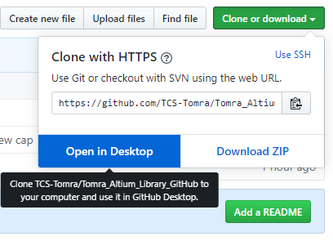

From now on use the desktop application to:

* Create a local clone of the “Tomra_Altium_Library_GitHub” repository on a local folder. This is from now on your local working folder.
* To update local files, click “Fetch” or “Repository -> Pull”

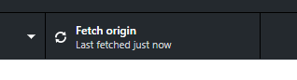

To change or add a component, the files are edited locally as normal and then pushed to the repository.

* When a file is changed it will be listed under “Changes” in the desktop application.

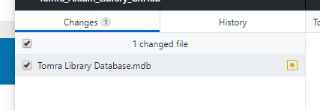

* To upload these changes to the repository to steps are required
  1. Commit the changes with a short description

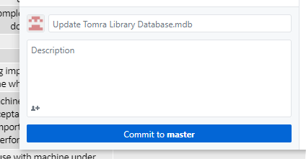

* 1. Push the changes to the repository

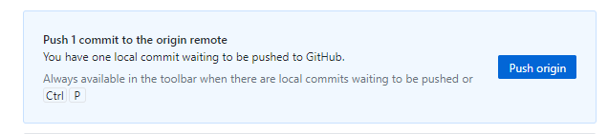

## Using the GitHub library in Altium

* Make sure you are running 64-bit version of Office, with Access installed.   
  This can be downloaded from office.com -> Installer Office -> Andre alternativer for installasjon -> choose 64-bit -> Innstaller Office.
* Download and install [64-Bit (x64) Microsoft Access Database Engine](https://www.microsoft.com/en-us/download/details.aspx?id=54920).
* Open Altium and start a new schematic.
* Go to Tools -> Data Management -> File-based Libraries -> Install from file -> browse to the local clone repository “Tomra_Altium_Library_GitHub” -> open “Tomra Library.DbLib”.
* The library should now appear in the Installed Libraries list. 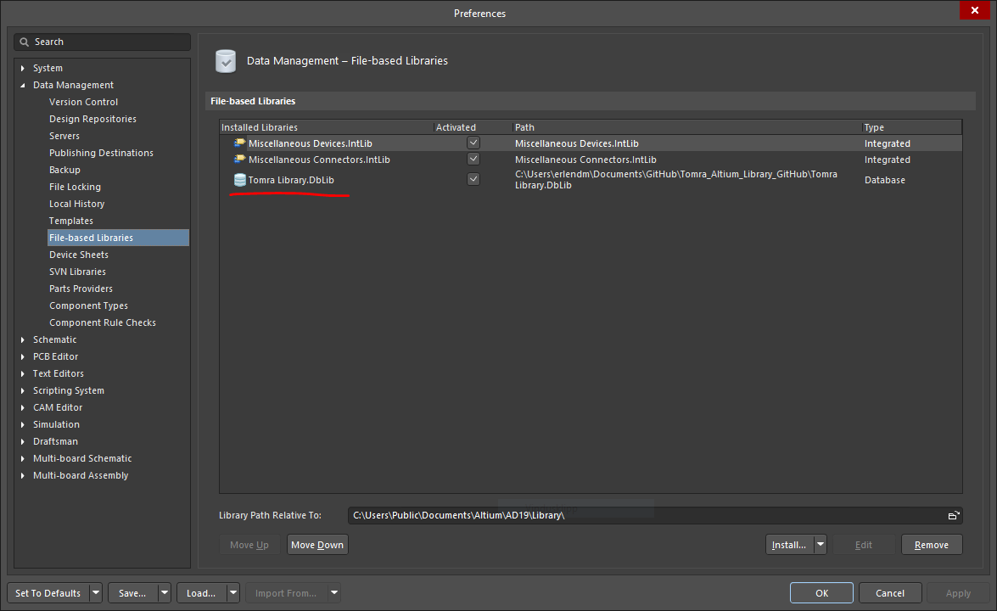

When using the library, it is important to keep the local files up to date by performing a “Pull” or every now and then – at least once daily.

## Known issues

Sometimes when Altium is opened the database file (.mdb) is slightly changed and GitHub register this as a change. It is not necessary to push these changes to the repository.

* In GitHub desktop, right click the .mdb file and select “Discard Changes”, with Altium designer closed. When this is done the latest version of the repository can be pulled without problems.

The “.ldb” file is always changed when Altium or Access is opened. This file keeps track of who is accessing the file at a certain point. It is not necessary to push changes of this file to the repository and it can be added to gitignore.

# Symbols

The library is based on component data from the Tomra Cadstar library. In the process of importing this data symbols and footprints was also imported. These symbols and footprints are not really adopted to be directly used in Altium and must edited before taken in use. Typical for symbols is for example, that the pin length is set to 0 and that the pin names are free text instead the actual pin names.

Footprints from Cadstar can be easily spotted by that they do not include a 3D model – all footprints created for Altium shall include a 3D model. It is also visible in the path column in the database file, since it is pointing to “Tomra_Cadstar_Footprints.PcbLib”.

## Edit symbol for Altium use

A symbol that has been directly imported from Cadstar can quite easily be adjusted for Altium use by performing the following steps.

* Edit symbol in the library in Altium
* Select all pins. For example, by right clicking one of them using “Find similar objects”.
  1. Set length to 200mil
  2. Set designator to visible
* Move pins to correct positions.
* Add pin names (these are imported as free text)
* Add rectangle. (Place -> rectangle)

## General

What properties to be included on certain component types, what stems to be used etc has been defined in “Tomra CADSTAR - Library Definition.pdf” available here:

K:\Library Documentation\Tomra CADSTAR - Library Definition.pdf

Many of the recommendations in the document above are still valid and there is no reason to change them.

Below are recommendations on how to draw symbols that are Altium specific

* Naming of the symbol shall follow the Tomra standard for components, specified in the document linked above. The symbols name or “Design Item ID” shall be the same as the “Description” of the component in the library.
* The “Description” in the symbol shall have value “=Description”. This ensures that the description is fetched from the library database.
* The “Designator” must have value “U?”, “R?”, “J?” etc depending on component type. See the document linked above for more stems.

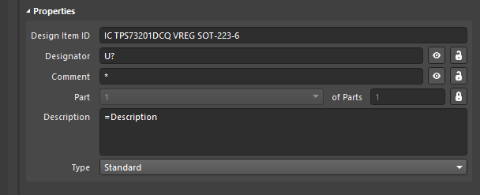

* Place the component with the top left corner of the “body” in origin. This ensures that placement of reference designator and “comment” will be correct when the symbol is placed in the schematic.

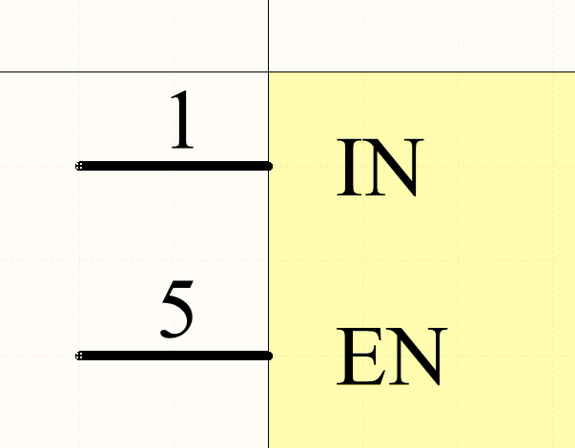

* The symbol shall not have any parameter values. All parameters are collected form the library database.
* Do not place pins vertically if not necessary. This means that there is space for “refdes” and “comment” above and below the component in the schematic.
* All pins shall be placed at a 100-mil grid.

## IC

* Pin length 200mil
* Pin number visible on pin
* Pin name visible
* Pale yellow background
* Symbols should be split into several sub-symbols if suitable. For example, power pin on a separate sub-symbol.

## Connectors (Micro-fit, pin headers and similar)

* Pin length 200mil
* Both pin number and name should be the number of the pin
* Only pin name visible (no need to show the number twice)
* Notation of what the pin actually is used for should be done in free text in the schematic
* Normally 200mil spacing between pins
* Pale yellow background

# Drawing Schematics

Below are recommendations on to draw schematics, this is mainly to get a similar look and feel for all schematics drawn in Tomra.

Schematics shall typically be drawn with a signal flow from left to right. I.e. place input signals on the left side and outputs on the right.

* Ports are to be used for signals going to other sheets
* It is often better to use net labels than long wires when two pins far away from each other are to be connected.
* Net labels are to be used for nets local on sheet. (The “Net Identifier Scope” setting defines if Net Labels are global or local to one sheet. In a flat design, this is typically set so that only power ports are global, meaning that ports *must* be used for off sheet signals)
* Capitals shall be used for net labels and ports.
* Use suffix “n” for active low signals
* A “Power port” of style “bar” shall be used to voltage rails. The name is adjusted to for example “5V”, “3V3”, “1V8”… negative supplies shall be “-12V”, “-5V”…

## Components that are not to be mounted

More or less all design contains components that are not to be mounted. Using variants in Altium simplifies the way this is handled and makes it easy to export a BOM for example. However, in the normal editor mode in Altium, it is not visible if a certain component is to be mounted or not.

* Variants shall be used. For example, a variant called “Mounted”.
* In addition, a parameter named DNM shall be added to the component to indicate that the part is not mounted also when in “Editor” mode. This parameter shall be visible in the schematic.

It is important to note that if symbols are later updated from the library, the DNM property can be removed, depending on settings. If an update is done only to import new footprints it is recommended just to update “models” and nothing else.

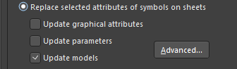

## Template

Schematic templates have been created for A4, A3 and A2. These are located in

“(your local repository folder)\DOC\Templates”

And are selected by on the “Page Options”.

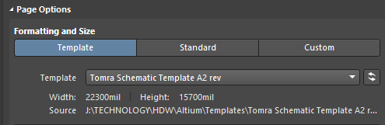

# Footprints

When possible footprints compliant with IPC-7351, nominal size, shall be used. The footprint wizard in Altium is good tool for creating such footprints. Footprints can also be found using the “Manufacturer Part Search” panel, but they do however require some modification to match our requirements. 3D models can be found from the manufacturer, 3DContentcentral, or simple models can be created in Altium. All footprints shall include a 3D model.

* The name of the footprint shall preferably be according to the IPC-7351 standard. If connectors or other special components the MPN of the part should be used.
* Origin of the components shall be placed in the centre of the footprint. Except for connectors where this might not be suitable.
* Pads shall normally be of type “Rounded Rectangle” for better soldering properties.
* Pads shall be set to paste and solder mask expansion from “Rule”. This means that solder and paste mask expansions are controlled from the design rules in each layout.

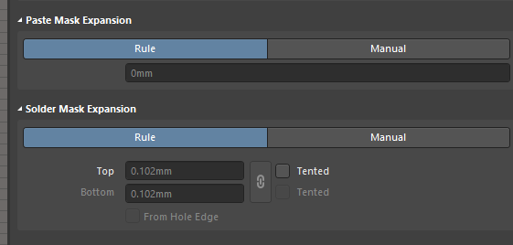

## Layer utilization

Mechanical 13: 3D body and assembly drawing. A 3D body shall be included on all components. “.Designator” must be included here for use on the assembly drawing. The lines on this layer shall have width 0.1mm, and a pin 1 marking must be included on components where this is relevant.

Mechanical 15: Courtyard. Placement guide for the component. Typically, a 0.05mm thick line 0.2mm outside the pads and component body. A centre marking shall also be included on this layer.

Mechanical 31: Optional use for component body drawing, for example DXF from the manufacturer.

Top Overlay: This is the silkscreen layer. Preferred line width 0.15mm. Keep clear of pads with at least 0.2mm. A pin 1 marking shall be included where relevant, normally a dot for ICs. For connector it is preferred that actual number are written.

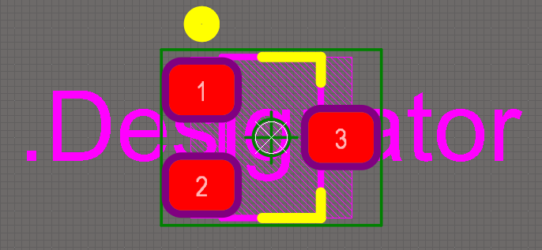

Figure 1: Example footprint

# Layout

## Layer utilization

Mechanical 1: Board outline. The outline is typically drawn with a 0.2mm line and then defined as the actual outline of the board using “Design -> Board Shape -> Define from selected objects”

Mechanical 2: Dimensions

Mechanical 13/14: To get a correct assembly drawing, with two views, one for top and one for bottom, a “Layer Pair” must be created. This means that the drawing on a certain layer is automatically moved to a different layer when a component is flipped from one side to the other. Since layer 13 is used for assembly information in the library, for example layer 14 can be used for assembly information for the bottom side. To create the layer pair right click “Component Layer Pairs” in “View Configuration” and select “Add Mechanical Layer”. Below is a suggestion on the configuration:

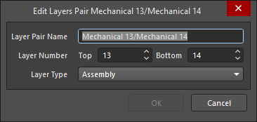

## Design Rules

The design rules will differ from design to design but to give an example the design rules for board C644 has been exported to:

“(your local repository folder)\DOC\Examples”

This can be imported in to Altium Designer to give a starting point for similar boards.

## Drill Table

A drill table shall be included on the layer called “Drill Drawing”. This is placed with “Place -> Drill Table”.

## Output Job Files

To export documentation (schematics, gerber, 3D-files etc) from Altium, ‘Output-job’ files are used. You can either create one from scratch by pressing **File->New->Output Job File** or you can add a pre-configured example from Github, for example **C655.OutJob** in the folder:

“(your local repository folder)\DOC\Examples”.

When adding an example file, it’s best to copy it into the project folder first and then re-naming it according to the board design number. Then go to the Projects panel, right-click on the **<project>.PrjPcb** file, choose “**Add existing to project**” and select the OutJob file from the project folder.

A more indepth guide is given here : <https://www.altium.com/documentation/altium-designer/preparing-multiple-outputs-in-an-outputjob-ad?version=18.1>

## Generating BOM

Before generating BOM, make sure you are using the correct BOM template.   
In the **<project>.OutJob** file, right-click on “**Bill of Materials**” and choose “**Configure**”. Make sure the “**Tomra BOM Template**” is selected from the folder:

“(your local repository folder)\DOC\Templates”.

Next, make sure the correct Columns are selected (i.e. which parameter the BOM will sort by). In the “**Columns**” tab, make sure “**LibRef**” is the only column selected. End by pressing “OK”.

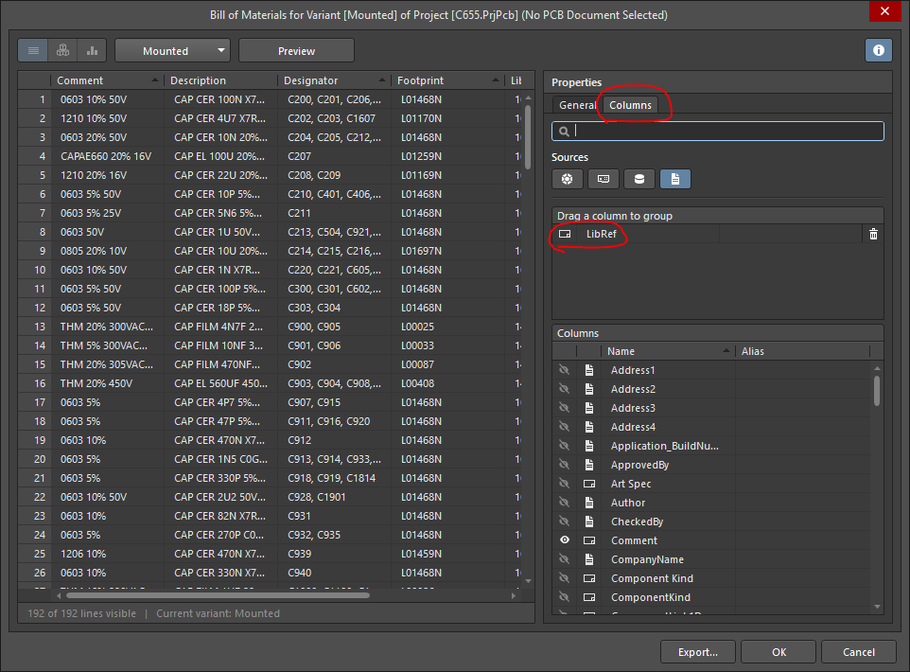

## Generating Gerber Files

* Recommended setting for Gerbers are “millimetres and format 4:4 for good precision.
* A separate layer with only the outline, typically, mechanical 1 shall be included
* It is also recommended to include the outline on all plots.

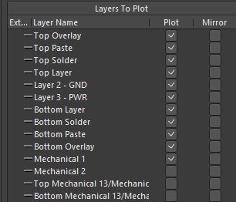

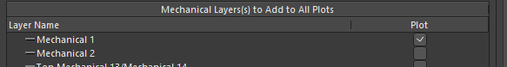

# MCAD Cooperation

Altium has support for tight integration with a number of MCAD tools, unfortunately not (yet) Siemens NX.

However, it is a great advantage to have a 3D model of all components in the Altium library, therefore it is mandatory to create (or import) a 3D model when a component is added to the library. Having 3D models of all components in the library also enables export of quite accurate 3D files of the board. Testing has shown that export of Parasolids works better with NX and gives more accurate models than Step files.

It is also possible to use IDF files for cooperation with MCAD, this has yet been briefly tested so far. But there are limitations in the IDF format and components are only modelled as boxes.

To get a starting point with a board design it is possible to import a DXF or Step file that can be used to define the outline of the board and for example some critical connectors.

# Tips and Tricks

## Schematic

* The grid can be toggled by just hitting the letter “g” on the keyboard.
* Drop down menus are all available with shortcuts. For example, for placing a wire, hit “p” for place and “w” for wire.
* While drawing a wire or routing a track “tab” can be pushed to pause the ongoing command to adjust settings
* “Back space” deletes the last segments of track or wires
* A net is highlighted by alt+left click
* A port is followed by crtl+double click

## Layout

# For the future…..

* Link to Teamcenter – if teamcenter is to continue to the be the real source of information
* Altium Concord Pro – gives proper revision control of components and designs, could especially important if the organization grows.